Baroque
is often thought of as a period of artistic style that used exaggerated motion and clear, easily interpreted detail to produce drama, tension, exuberance, and grandeur in sculpture, painting, architecture, literature, dance, and music. The style began around 1600 in Rome, Italy and spread to most of Europe.
The popularity and success of the Baroque style was encouraged by the Catholic Church, which had decided at the time of the Council of Trent, in response to the Protestant Reformation, that the arts should communicate religious themes in direct and emotional involvement. The aristocracy also saw the dramatic style of Baroque architecture and art as a means of impressing visitors and expressing triumph, power and control. Baroque palaces are built around an entrance of courts, grand staircases and reception rooms of sequentially increasing opulence. However, 'baroque' has resonance and application that extend beyond a simple reduction to either style or period.
The word baroque is derived from the Spanish "barroco", or French "baroque", all of which refer to a "rough or imperfect pearl. In informal usage, the word baroque can simply mean that something is "elaborate", with many details, without reference to the Baroque styles of the 17th and 18th centuries.
Though Baroque was superseded in many centers by the Rococo style, beginning in France in the late 1720s, especially for interiors, paintings and the decorative arts, the Baroque style continued to be used in architecture until the advent of Neoclassicism in the later 18th century. See the Neapolitan palace of Caserta, a Baroque palace whose construction began in 1752.

Periods
The Baroque era is sometimes divided into roughly three phases for convenience:
- Early Baroque, c.1590–c.1625
- High Baroque, c.1625–c.1660
- Late Baroque, c.1660–c.1725
Late Baroque is also sometimes used synonymously with the succeeding Rococo movement.

Baroque characteristics
Among the general characteristics of baroque art is a sense of movement, energy, and tension (whether real or implied). Strong contrasts of light and shadow enhance the dramatic effects of many paintings and sculptures. Even baroque buildings, with their undulating walls and decorative surface elements, imply motion. Intense spirituality is often present in works of baroque art; in the Roman Catholic countries, for example, scenes of ecstasies, martyrdoms, or miraculous apparitions are common. Infinite space is often suggested in baroque paintings or sculptures; throughout the Renaissance and into the baroque period, painters sought a grander sense of space and truer depiction of perspective in their works. Realism is another integral feature of baroque art; the figures in paintings are not types but individuals with their own personalities. Artists of this time were concerned with the inner workings of the mind and attempted to portray the passions of the soul on the faces they painted and sculpted. The intensity and immediacy of baroque art and its individualism and detail—observed in such things as the convincing rendering of cloth and skin textures—make it one of the most compelling periods of Western art.
the use of movement, whether actual (a curving wall, a fountain with jets of water forever changing shape) or implied (a figure portrayed as making a vigorous action or effort); the attempt to represent or suggest infinity (an avenue which stretched to the horizon, a fresco giving the illusion of a boundless sky, a trick of mirrors which altered perspectives and made them unrecognizable); the importance given to light and its effects in the conception of a work of art and in the final impact it created; the taste for theatrical.

Architecture
In Baroque architecture, new emphasis was placed on bold massing, colonnades, domes, light-and-shade (chiaroscuro), 'painterly' color effects, and the bold play of volume and void. In interiors, Baroque movement around and through a void informed monumental staircases that had no parallel in previous architecture. The other Baroque innovation in worldly interiors was the state apartment, a sequence of increasingly rich interiors that culminated in a presence chamber or throne room or a state bedroom. The sequence of monumental stairs followed by a state apartment was copied in smaller scale everywhere in aristocratic dwellings of any pretensions. Baroque architecture was also characterized by what is now known as town planning: the arrangement of cities according to predetermined schemes, and the creation of great parks and gardens around residences of importance.
The fundamental characteristic of Baroque art is dynamism (a sense of motion). Strong curves, rich decoration, and general complexity are all typical features of Baroque art. The full Baroque aesthetic emerged during the Early Baroque (ca. 1600-25), then culminated during the High Baroque (ca. 1625-75); both periods were led by Italy. . The Late Baroque and Rococo periods were led by France.
Baroque architecture is distinguished primarily by richly sculpted surfaces. Whereas Renaissance architects preferred planar classicism (flat surfaces veneered in classical elements), Baroque architects freely moulded surfaces to achieve three-dimensional sculpted classicism And while the surface of a Renaissance building is typically neatly divided into sections (in accordance with classical clarity and order), a Baroque surface is treated as a continuous whole.
Indeed, a Renaissance facade often consists of many similar sections, such that one's eye is not drawn to any particular part of the building. A Baroque facade, on the other hand, often features an attention-grabbing concentration of rich elements (e.g. curved walls, columns, blind arches, statues, relief sculpture) around a central entrance.Churches are the most splendid form of Baroque architecture in Italy, while chateaux (country mansions) are the outstanding Baroque works of France.

Early Baroque ca. 1600-1625
The foremost pioneer of Baroque architecture was Carlo Maderno, whose masterpiece is the facade of Saint Peter's Basilica, Vatican City(Constructed under various architects throughout the sixteenth and seventeenth centuries, Saint Peter's features a mixture of Renaissance and Baroque components, the facade being one of the latter.)
- 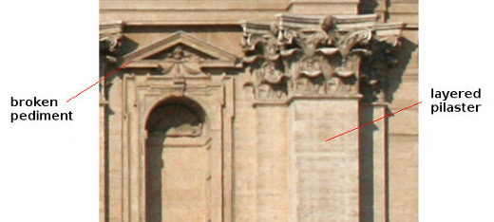
Example of Broken Pediment and Layered Pilaster (Saint Peter's Basilica)
- 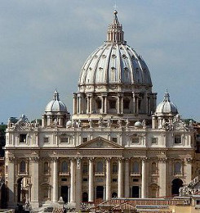
Saint Peter's Basilica
- 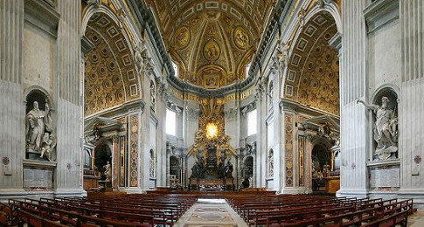
Saint Peter's Basilica
The facade of Saint Peter's contains a number of typical Baroque elements, including double columns (close-set pairs of columns), layered columns, colossal columns (columns that span multiple stories), and broken pediments (in which the bottom and/or top of a pediment features a gap, often with ornamentation that "bursts through" the pediment). St Peter's also makes extensive use of coffered ceilings, a common feature of monumental Western architecture. (A "coffer" is a sunken ceiling panel, typically square, rectangular, or octagonal in shape.)

High Baroque ca. 1625-75
The two foremost names in Baroque architecture are Bernini and Borromini, both of whom worked primarily in Rome.
Two masterpieces of Bernini are found at St Peter's. One is the four-story baldachin that stands over the high altar. (A baldachin is an indoor canopy over a respected object, such as an altar or throne.)
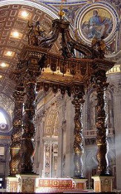
Baldachin at Saint Peter's, Bernini

The other is the curving colonnades that frame St Peter's Square.
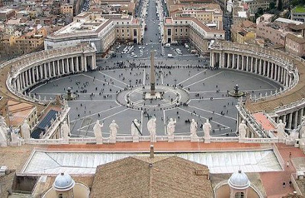
Saint Peter's Square, Bernini
Bernini's most famous building is likely the small church of Sant'Andrea al Quirinale ("Saint Andrew's on Quirinal Hill"). Quirinal hill is one of the "seven hills of Rome".
- 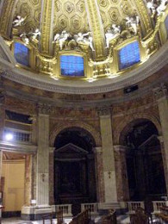
Sant'Andrea al Quirinale, Bernini

Francesco Borromini was the master of curved-wall architecture. Though he designed many large buildings, Borromini's most famous and influential work may be the small church of San Carlo alle Quattro Fontane ("Saint Charles at the Four Fountains"). This building is also found on Quirinal Hill.
- 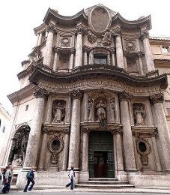
Church of San Carlo alle Quattro Fontane, Borromini
- 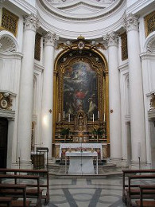
Church of San Carlo alle Quattro Fontane, Borromini
Credit: Chris Nas
- 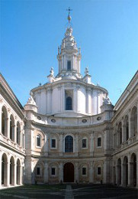

Church by Borromini

Late Baroque ca. 1675-1725
The Late Baroque marks the ascent of France as the heart of Western culture. Baroque art of France tends to be restrained, such that it can be described as a classical-Baroque compromise. The most distinctive element of French Baroque architecture is the double-sloped mansard roof (a French innovation).
- 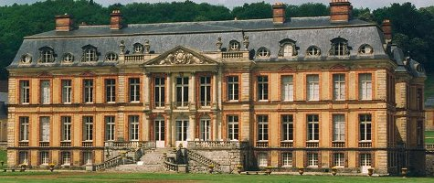
Baroque French Chateau
- 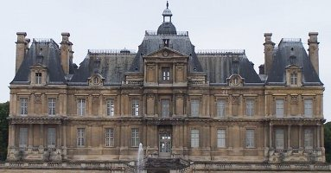
Baroque French Chateau
The most famous Baroque structures of France are magnificent chateaux (grand country residences), greatest of which is the Palace of Versailles. One of the largest residences on earth, Versailles was built mainly under Louis XIV. The palace facade admirably illustrates the classical-Baroque compromise of northern Europe. The walls are characterized largely by simple planar classicism, although they do contain such Baroque elements as sculpted busts, a triple stringcourse, double pilasters, and colossal pilasters. Additionally, the mansard roof features a sinuous metal railing and rich moulding around the dormer windows. Versailles became Europe's model of palace architecture, inspiring similarly grand residences throughout the continent.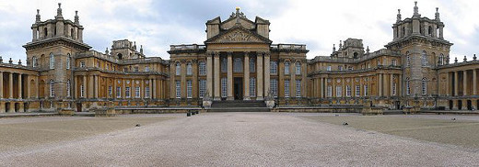
English Palace inspired by Versailles
- 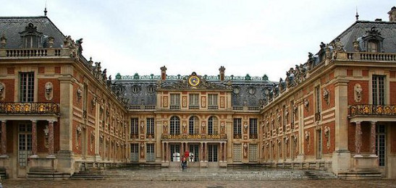
Facade of Versailles

Theatre
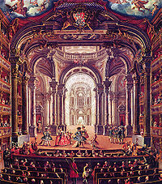

18th-century painting of the Royal Theatre of Turin
Theatre evolved in the Baroque era and became a multimedia experience, starting with the actual architectural space. In fact, much of the technology used in current Broadway or commercial plays was invented and developed during this era. The stage could change from a romantic garden to the interior of a palace in a matter of seconds. The entire space became a framed selected area that only allows the users to see a specific action, hiding all the machinery and technology – mostly ropes and pulleys.
This technology affected the content of the narrated or performed pieces, practicing at its best the Deus ex Machina solution. Gods were finally able to come down – literally – from the heavens and rescue the hero in the most extreme and dangerous, even absurd situations.

Painting

Early Baroque ca. 1600-25
The founder of the realist Baroque aesthetic was Caravaggio, the most influential painter of the Early Baroque period, and the artist who established tenebrism (the bright illumination of a scene out of darkness) as a common feature of realist Baroque painting. Given its drama-heightening effect, tenebrism is very much a Baroque effect (see Western Aesthetics). The impact of this effect can be seen in The Musicians, one of Caravaggio's most famous non-religious works, and The Calling of Saint Matthew, possibly his masterpiece.
Caravaggio evoked much controversy with his bold embrace of reality. In religious paintings, for instance, he faced widespread opposition to his depictions of biblical figures with realistic bodies and features; this marks a sharp break from Renaissance idealism, in which figures are generally muscular and youthful, and have flawless, generic faces. Moreover, Caravaggio's work often features impoverished people and places; The Calling of Saint Matthew, for instance, is set in a run-down tavern.
- 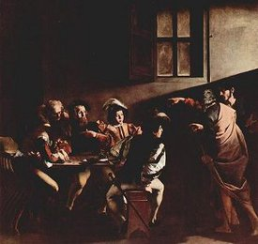
The Calling of Saint Matthew
- 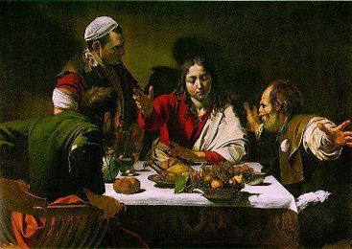
Supper at Emmaus

High Baroque ca. 1625-1675
Rembrandt van Rijn, a realist Baroque artist, is often considered the greatest of all Dutch painters. Rembrandt embraced tenebrism, but in a softer, more atmospheric manner than Caravaggio. His leading works include Nightwatch (his masterpiece) and Aristotle with a Bust of Homer.

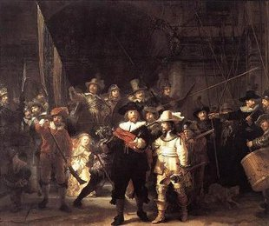
Nightwatch
- 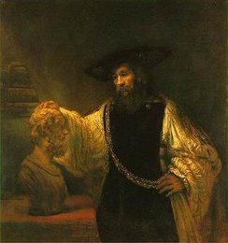
Aristotle with a Bust of Homer
In addition to figure paintings, French classicism also embraced landscapes. The resulting images were not realistic, however, but imaginary classical landscapes in which the terrain and its features are arranged in a balanced, harmonious manner. Indeed, equivalent works were produced by dynamic Baroque artists: imaginary dynamic Baroque landscapes, arranged in a dynamic, dissonant manner, often with restless weather and dramatically curved roads and rivers.
- 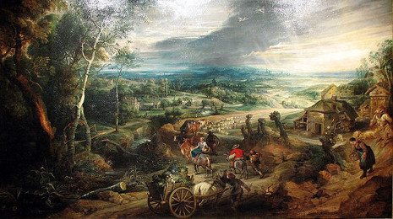
Dynamic Baroque Landscape

Baroque style featured "exaggerated lighting, intense emotions, release from restraint, and even a kind of artistic sensationalism". Baroque art did not really depict the life style of the people at that time; however, "closely tied to the Counter-Reformation, this style melodramatically reaffirmed the emotional depths of the Catholic faith and glorified both church and monarchy" of their power and influence.
There were highly diverse strands of Italian baroque painting, from Caravaggio to Cortona; both approaching emotive dynamism with different styles.

Sculpture

Early/High Baroque
ca. 1600-1675
The Early and High Baroque periods were spanned by the career of Bernini, the founder and greatest master of Baroque sculpture. His magnificent Cathedra petri ("Chair of Saint Peter"), which consists of a throne (behind the altar at St Peter's) surrounded by sculptural decoration, is the crowning work of High Baroque extravagance. Bernini's statues include Ecstasy of St Theresa and numerous angels.
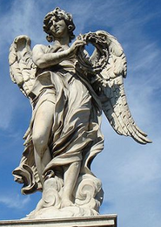

Angel with Crown of Thorns
- 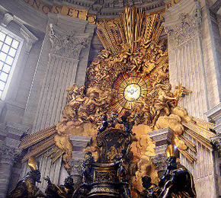

Cathedra Petri
In Baroque sculpture, groups of figures assumed new importance and there was a dynamic movement and energy of human forms—they spiraled around an empty central vortex, or reached outwards into the surrounding space. For the first time, Baroque sculpture often had multiple ideal viewing angles. The characteristic Baroque sculpture added extra-sculptural elements, for example, concealed lighting, or water fountains. Aleijadinho in Brazil was also one of the great names of baroque sculpture, and his master work is the set of statues of the Santuário de Bom Jesus de Matosinhos in Congonhas. The soapstone sculptures of Old Testament prophets around the terrace are considered amongst his finest work.
The architecture, sculpture and fountains of Bernini (1598–1680) give highly charged characteristics of Baroque style. Bernini was undoubtedly the most important sculptor of the Baroque period. He approached Michelangelo in his omnicompetence: Bernini sculpted, worked as an architect, and painted,. In the late 20th century Bernini was most valued for his sculpture, both for his virtuosity in carving marble and his ability to create figures that combine the physical and the spiritual. He was also a fine sculptor of bust portraits in high demand among the powerful

Bernini's Cornaro chapel

A good example of Bernini's Baroque work is his St. Theresa in Ecstasy (1645–52), created for the Cornaro Chapel of the church of Santa Maria della Vittoria, Rome. Bernini designed the entire chapel, a subsidiary space along the side of the church, for the Cornaro family
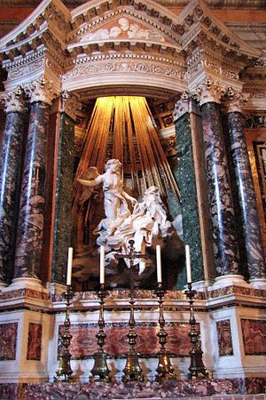
Bernini's Ecstasy of St. Teresa
Saint Theresa, the focal point of the chapel, is a soft white marble statue surrounded by a polychromatic marble architectural framing. This structure conceals a window which lights the statue from above. Figure-groups of the Cornaro family sculpted in shallow relief inhabit opera boxes on the two side walls of the chapel. The setting places the viewer as a spectator in front of the statue with the Cornaro family leaning out of their box seats and craning forward to see the mystical ecstasy of the saint.
St. Theresa is highly idealized and in an imaginary setting. She was a popular saint of the Catholic Reformation. She wrote of her mystical experiences for an audience of the nuns of her Carmelite Order; these writings had become popular reading among lay people interested in spirituality. In her writings, she described the love of God as piercing her heart like a burning arrow. Bernini materializes this by placing St. Theresa on a cloud while a Cupid figure holds a golden arrow made of metal and smiles down at her. The angelic figure is not preparing to plunge the arrow into her heart—rather, he has withdrawn it. St. Theresa's face reflects not the anticipation of ecstasy, but her current fulfillment.
This work is widely considered a masterpiece of the Baroque, although the mix of religious and erotic imagery may raise modern eyebrows. However, Bernini was a devout Catholic and was not attempting to satirize the experience of a chaste nun. Rather, he aimed to portray religious experience as an intensely physical one. Theresa described her bodily reaction to spiritual enlightenment in a language of ecstasy used by many mystics, and Bernini's depiction is earnest.

Late Baroque sculptures
ca. 1675-1725
In the Late Baroque period, Italy was superseded by France as the cultural heart of the West. The architectural masterpiece of the age is the Palace of Versailles, graced with many fine Late Baroque statues. These Versailles statues, which embody the aforementioned restrained Baroque aesthetic, may be considered the collective sculptural masterpiece of the Late Baroque period.
- 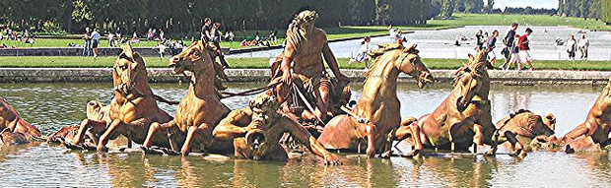
Statue in the Park of Versailles

- 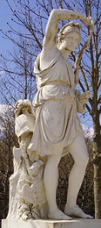
- Statue in the Park of Versailles

Italian Baroque interior design:

Italian Baroque interior design refers to high-style furnishing and interior decorating carried out in Italy during the Baroque period, which lasted from the early 17th to the mid-18th century. In provincial areas, Baroque forms such as the clothes-press or armadio continued to be made into the 19th century.

History, influences and background
In the late 16th century, Rome was the seat of an extremely powerful and influential papacy. Due to this Catholic Reformation, popes in Rome hired several architects, painters and interior designers to re-decorate the city and improve its public decorum,^{[1]} creating several new palaces and churches, and re-designing the interiors of several papal buildings. Decorations were richer and more grandiose than those of the Renaissance, and this movement evolved into the Baroque, which later spread across the whole of Italy and later Europe.
Since this was an age where learning and patronage of the arts were considered desirable pursuits for nobles, the bookcase came out of the private studiolo to furnish state apartments as an object of display. Among new forms of furniture in parade apartments, free-standing bookcases were no longer built into the structure of rooms. Lavish bookcases started to be made, often with gilded marble columns and intricate designs.
Roman carvers' shops outshone the more modest craft of cabinetmaking, as demanding commissions overseen by architects for carved decors, frames, altar candle stands, confessionals and pulpits came in a steady stream for the furnishings of churches and semi-public chapels. In secular apartments of parade, richly carved, painted and gilded frames came from the same shops. Carved frames and case furniture had come to rival the former primacy of textiles during the course of the 16th century. Baroque objects were grand in scale in proportion to the interiors they occupied, and would be ornamented with cartouches, swags and drops of boldly-scaled fruits and flowers, open scrollwork and carvings of human figures, which swarmed over and all but effaced the tectonic forms that supported them which made them look majestic and royal in appearance.
The frescoed galleries of the city's many palazzi were lined with elaborate console tables set against the piers and between the windows. In ceilings the new popular style of frescoing emerged known as the quadratura from its elaborate framing, was reflected in the framing of large looking-glasses, assembled fromsix to eighteen panes of Venetian mirror-glass, themselves being made in larger dimensions than ever.
In Florence, grand cabinets known as stippone began to be produced in the ducal workshops, thought to have been inspired from Augsburg cabinets.^{[1]} They had many shells and carved foliages, and were decorated with expensive materials, such as gilt bronze, ebony and pietra dura.
In Genoa, grand console tables supporting huge marble slabs on carved gilt bases began to be made. The offer of an armchair continued to convey elite status: inventories record a single one or a pair in rooms where the seating otherwise was on armless side-chairs, sgabelli of traditional construction— now enriched with bold sculpture— and stools. Chairs made by the Genoese were made with rich fabrics, often silk or velvet, to accord with the hangings and were often gilded with gold or silver.
After the mid-17th century, the state bed also came to provide the expected climax of the sequence of rooms in a Baroque apartment, following precedents established in France. Late-17th century Italian beds were usually grand in scale, often with elaborate wooden backs and fabric drapes. They were usually similar in style throughout the nation, but the textiles varied by region.
Italian baroque furnishing also had considerable Eastern influences. Their furniture was mainly sumptuous and luxurious, and included rich silks and green and gold lacquer.
However, in Italy, there were considerable differences in the interior design of a grand palazzo than that of a normal house. Palazzi were usually lavish and sumptuous, whilst middle-class town/country houses were usually far plainer, with simple wooden beds, x-framed chairs and big cassoni, or chests.
Baroque style is characterized by aspiration for greatness and splendor: it features massive staircases, columns, pilasters. Interiors are decorated with colored marble, sculptures, stucco, paintings, moldings and carvings. Mirrors and paintings visually expand the space. Walls are usually hung with expensive fabrics and tapestries. Favorite colors are blues, greens, reds and gold. From classicism Baroque inherited symmetry which gives interiors decorated in this style formal and solemn look.
Theatrical effect
Everything in Baroque style interior was aimed to impress and thrill. Bed was usually given the primary role: decorated with ostrich feathers and covered with splendid fabrics it always was the focal point in the room.
Trophies
Ancient Roman trophies were often used as a part of decor to demonstrate the strength and power of the owner. It became especially popular in the early phase of Louis XIV government. They were usually depicted as a heap of helmets, swords, pears, flags, shields. This element was very often used in formal portraits:

Floral and ornate motifs
Floral motifs are widely used in the Baroque period. Among the favorite ornaments were acanthus leaves, water lily leaves, palm leaves, branches of laurel, olive and oak tree, scrolling foliage and garlands of fruits and flowers.
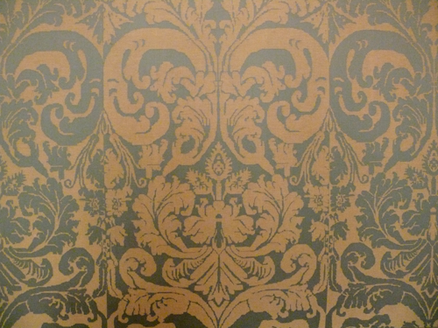
Example of fabric in Baroque style. Very often it was used as wall covering.
Cupids
Chubby children often called by Italian word “Putti” as well as cupids with wings are very popular motif used on many Baroque objects.
Gilt-wood
Gilt-wood furniture with luxurious ornaments incorporating foliage, animals, masks and twirls is one of the distinctive features of the Baroque era.
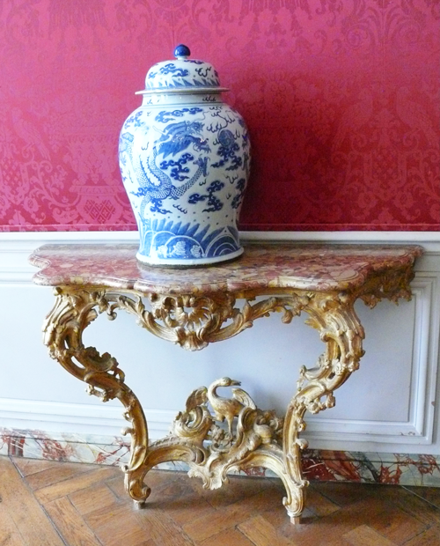
Baroque is one of the historical styles which remains popular until now and inspires many modern interior and furniture designers.

Different sorts of furniture
Pedestal Cabinet
The term Baroque is applied to a very ornate, exaggerated style. Again, there are regional differences within the Baroque genre, but in general, the style has a theatrical quality, with its features almost wanting to break out into the space of the observer.
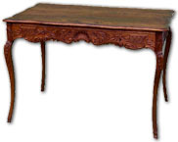
Main characteristics:
- Heavily ornate with expensive materials. Features were sculptural and implied dramatic movement. S and C-scrolls.
- Figural subjects “holding” the furniture up.
- Large and strictly symmetrical. Appearance came before function.
- Walnut, ebony, ivory, silver. The use of ormolu – or gilt bronze – in inlays.
- Chairs with high backs, squared legs with curved, diagonal stretchers.
- Marquetry on wardrobes – called armoires – depicted famous events.
- Japanning, an Asian style of lacquer work, became common ornament on cabinets.

Gilded frames
Gilded frames were very frequently used in paintings and mirrors, and usually consisted of several cartouches, carved flowers and sculptural figures.
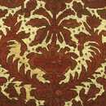
Mirror
Antoine Monnoyer
1710-1720
Mirrored glass, painted in oils, with stained wood frame

Cassoni
A cassone is an Italian chest; cassoni usually had a raised lid, often decorated with carved leaves and/or figures Cassoni found in rich people's houses were usually far more grand and elaborate, even though they were nearly always wooden, however more middle-class families' chests were simpler and still retained some Mannerist/Renaissance features, such as paw feet, strap work and segmented panels

(Florentine) Console tables
Florentine Console tables were and the table legs were mainly caryatids or muscular figures, made to look as if they were holding the marble slab on top. Most of their themes were copied or nearly identical to their Roman counterparts, but the Florentines became famous for these designs.

(Florentine) Cabinet
Florentine cabinets were usually very similar to those of the Renaissance in essence, except a few changes. Segments and strapwork was still used, however, it was also included new features such as pilasters, arched panels and pietra dura designs. Often religious or mythological themes were drawn inside the panels to add decoration to the object.
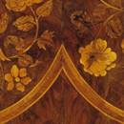
Cabinet
John Byfield
About 1700
Marquetry of walnut, burr walnut, sycamore, other woods and ivory, with some staining, on a pine and oak carcase, with brass fittings

Lion Commode
Lion commodes were often made of walnut or oak, pearl, jewels and ivory, which made fantastical and allegorical designs. They were often decorated with angels, animals, leaves, saints and flowers. They were called lion commodes specifically due to their lion-shaped feet at the bottom of the drawer.

Tables
Tables varied greatly during the Baroque period, but were often made of gilded wood, oak or walnut. Large tables were long, rich and sumptuous, whilst smaller ones were usually ornate and geometric.
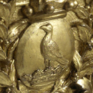
Table
James Moore
About 1714
Pine frame and oak top, carved, gessoed and gilded

Quadratura
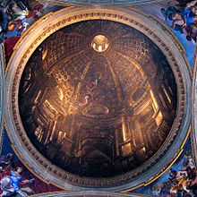
The illusionistic perspective of Andrea Pozzo's trompe-l'oeil dome at Sant'Ignazio (1685) creates an illusion of an actual architectural space on what is, in actuality, a slightly concave painted surface.
Quadratura, a term which was introduced in the 17th century and is also normally used in English, became popular with Baroque artists. Although it can also refer to the "opening up" of walls through architectural illusion, the term is most-commonly associated with Italian ceiling painting. Unlike other trompe-l'oeil techniques or precedent di sotto in sù ceiling decorations, which often rely on intuitive artistic approaches to deception, quadratura is directly tied to 17th-century theories of perspective and the representation of architectural space. Due to its reliance on perspective theory, it more fully unites architecture, painting and sculpture and gives a more overwhelming impression of illusionism than earlier examples.
The artist would paint a feigned architecture in perspective on a flat or barrel-vaulted ceiling in such a way that it seems to continue the existing architecture. The perspective of this illusion is centered towards one focal point. The steep foreshortening of the figures, the painted walls and pillars, creates an illusion of deep recession, heavenly sphere or even an open sky. Paintings on ceilings could, for example, simulate statues in niches or openings revealing the sky.
Baroque Ceilings
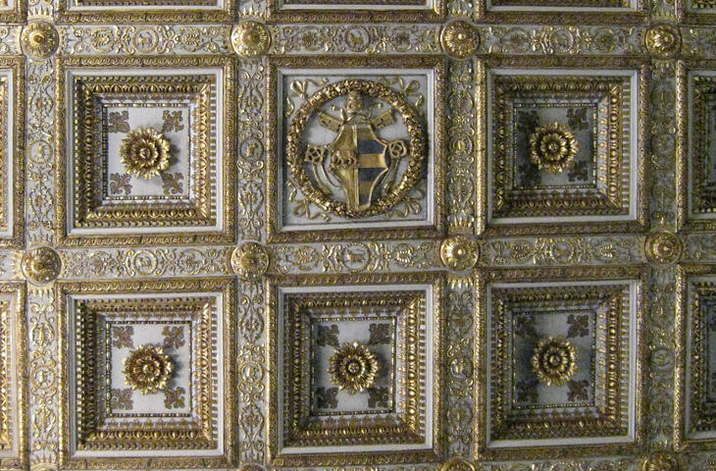
S.Maria Maggiore: Detail of the ceiling with the coat of arms of PopeAlexander I
The ceiling in S. Maria Maggiore served as model .these ceilings are called lacunar ceilings as they are decorated by painted or gilded cavities.
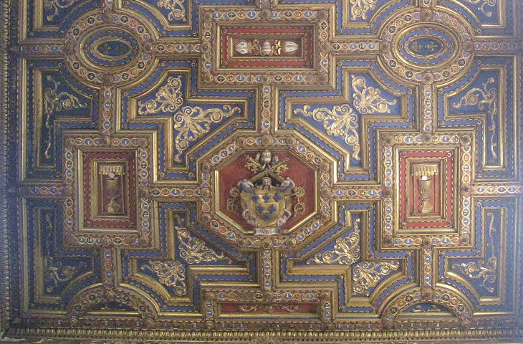
S. Spirito in Sassia: Detail of the ceiling with the coat of arms of Pope Paul III
At first the cavities (lacunae) had a regular quadrangular shape which highlighted the structural elements of the ceilings, but in the XVIth centuries this type of ceilings evolved and the shape and number of the lacunae were only dictated by decorative purposes. The lacunae housed coats of arms and other religious symbols. The success of these ceilings was constant through the whole XVIth century and well into the first decades of the XVIIth century
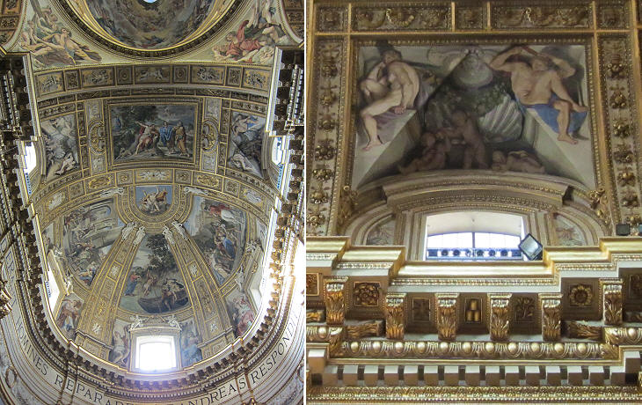
S. Andrea della Valle - Ceiling of the apse by Domenichino 1622-28 - Detail of a naked figure
The large churches built in Rome towards the end of the XVIth century had a different structure. They were closed by a vault similar to that of the Sixtine Chapel and when, usually some decades after the completion of the church, the issue of how best these ceilings should be decorated, the approach followed by Michelangelo in the Sixtine Chapel influenced the final decision. Domenichino (1581-1641) designed the ceiling over the apse of S. Andrea della Valle in 1622-28 when he was at the peak of his fame. He was the leader of the classical school and his neat partition of the space which clearly identified the painted spaces and the paintings themselves echoing ancient statues were considered a masterpiece. They were especially highly praised in the late XVIIIth century and during the whole XIXth century when a visit to S. Andrea della Valle was a "must" for any cultivated traveller. Domenichino paid homage to Michelangelo in the naked figures above the windows. He also made use of stucco statues on a gilded background: these statues are shown in the act of supporting the ceiling. The technique of using stucco had just been improved by adding to the mixture finely powdered marble. The statues of this ceiling appear very rigid and stuck to the ceiling.
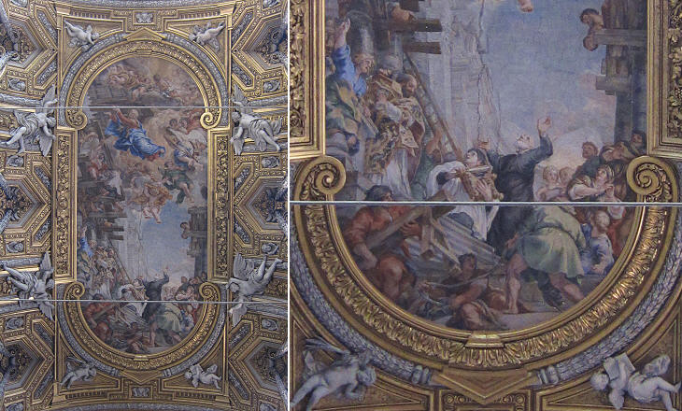
S. Maria in Vallicella: - Ceiling by Pietro da Cortona (painting) and Ercole Ferrata and Cosimo Fancelli (stuccoes) - 1647-66
In the ceiling of the nave the painted area is clearly separated from the gilded-stucco decoration and this is a point in common with the ceiling of S. Andrea della Valle. The stucco angels and putti were commissioned to scholars of Bernini who modelled them using a metal skeleton so that the statues look detached from the ceiling
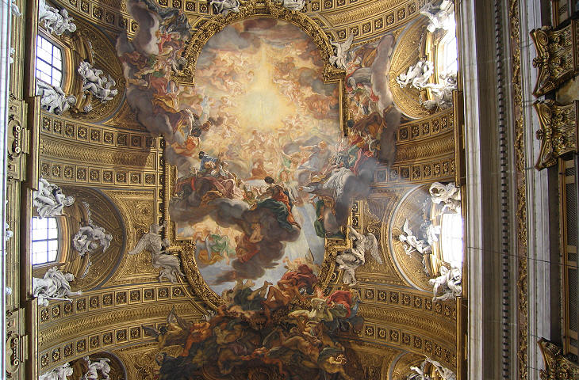
Il Gesù - Ceiling by Baciccio (painting) and Antonio Raggi and Leonardo Retti (stuccoes) - 1679
The design of the ceiling was suggested by Bernini, who had always been a supporter of combining architecture, sculpture and painting to impress the viewer. Here too we have a painting included in a cornice supported by stucco angels on a background of gilded decoration; and the painting (the Triumph of Jesus's name) is clearly divided into two parts, but the overall effect is much more dramatic.
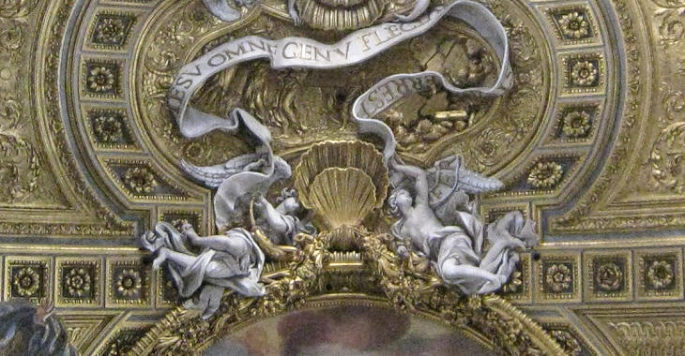
Il Gesù - Stuccoes by Antonio Raggi and Leonardo Retti
In the upper part of the ceiling the separation between painting, statues and decoration is very neat. The most striking aspect is the fact that the angels appear to be floating in the air.
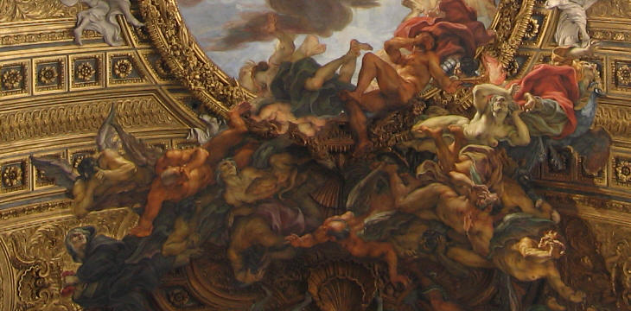
Il Gesù - Details of the painting by Baciccio
In the lower part of the ceiling all distinctions are forgotten. The mass of evils falling into Hell sweeps away the cornice and the angels and throws a shadow on the decoration. The sides of the cornice are broken by clouds upon which saints glorify Jesus's name; to add to the illusion Baciccio painted the shadow of the clouds on the gilded decoration. Today movies and TV have made us familiar with all sorts of visual tricks, but until the beginning of the XXth century viewers sat amazed under this illusionistic masterpiece, which, notwithstanding its being against all neoclassicist rules, was constantly praised by all travellers. This ceiling is considered a sort of watershed between Baroque and Late Baroque: the religious purpose of a work of art will gradually fade out and its technical, theatrical aspects will prevail.
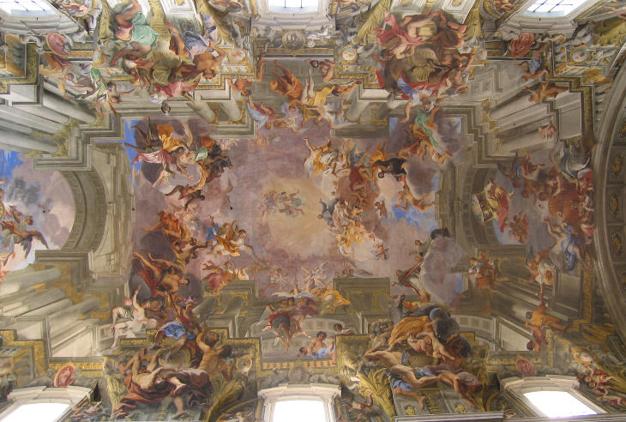
S. Ignazio - Ceiling by Andrea Pozzo - 1691-94
The Jesuits had another very large church in Rome: S. Ignazio. Its construction had gone on for a very long time, with the Jesuits asking for the advice of too many architects. The design of S. Ignazio included a dome at the intersection between the main nave and the transept, but at a certain point the Jesuits realized that the dome was no longer consistent with the already built parts of the church. As an interim solution they asked a Jesuit painter, Andrea Pozzo to cover the ceiling above the intersection between nave and transept with an apparent dome. The illusionistic effect reached by Pozzo was so satisfactory that S. Ignazio never got a dome and Pozzo was commissioned the decoration of the main nave.
Pozzo was expected to show again his illusionistic skills and he fully met these expectations. The entablature of the cornice, i.e. the framing of the ceiling among painted columns and architraves was not unusual, but Pozzo designed a sort of open ancient temple framing the sky with a myriad of figures, including allegories of the four continents. The subject of the painting - St. Ignatius' glory - is just a scene at the center of the ceiling.
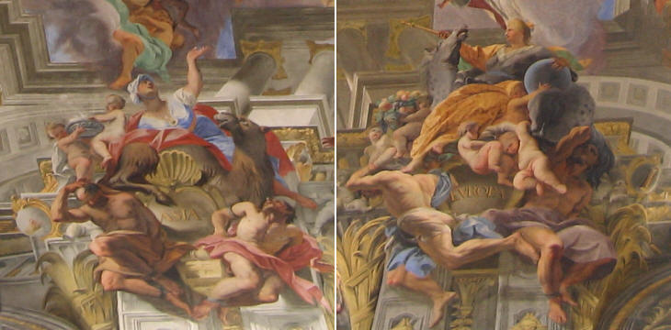
S. Ignazio - Ceiling by Andrea Pozzo - Details: (left) Asia - (right) Europe)
The illusion is perfect from any point in the nave, but the viewer is impressed by the skill, not by the drama, and ends by looking at the details, by testing the view of columns and arches from different angles. Pozzo wrote a book on perspective laws Perspectiva pictorum and architectorum which had a lasting influence on scenographers throughout the XVIIIth century.
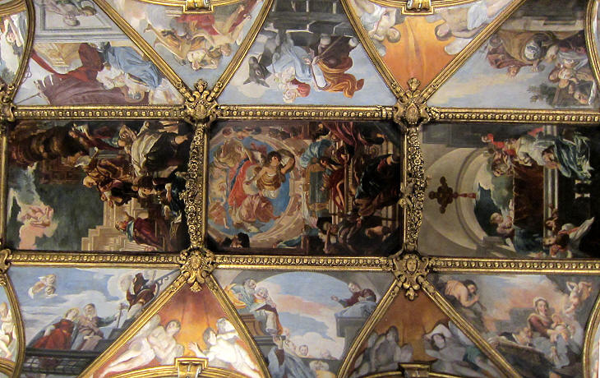
S. Maria in Trivio - Ceiling by Antonio Gherardi - 1667-69

Castle Howard, Yorkshire
Castle Howard is one of the grandest houses in Britain. It was built between 1701 and 1724 by John Vanbrugh, one of the great masters of the Baroque style. Castle Howard was the first building designed by Vanbrugh and he was assisted by Nicholas Hawksmoor, another celebrated Baroque architect. This partnership created the imposing classical exterior, its central block surmounted by a dome.
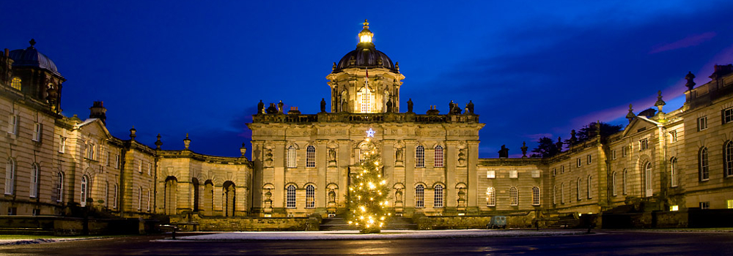

Burghley House, Lincolnshire
Burghley House in Lincolnshire was built in the 16th century by William Cecil, later Lord Burghley. The interior was remodelled by Burghley's descendant, the 5th Earl of Exeter, in the late 17th century. The Earl spent a vast amount of money on the project and employed the finest of craftsmen including the virtuoso woodcarver Grinling Gibbons. The most magnificent of the Baroque rooms is the Heaven Room, named after the painted decoration by the Italian artist Antonio Verrio which shows classical deities in an architectural setting.
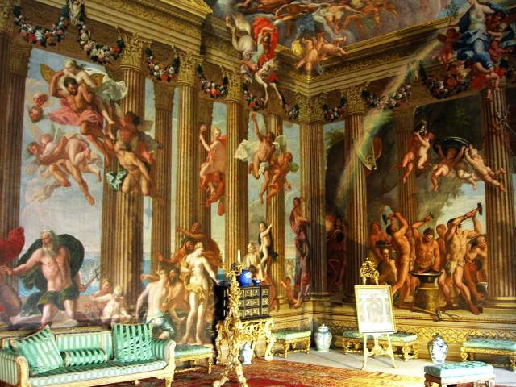

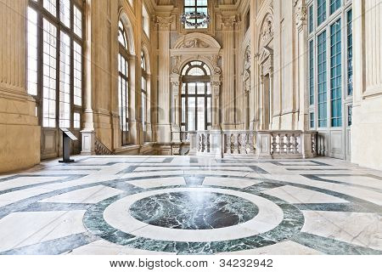
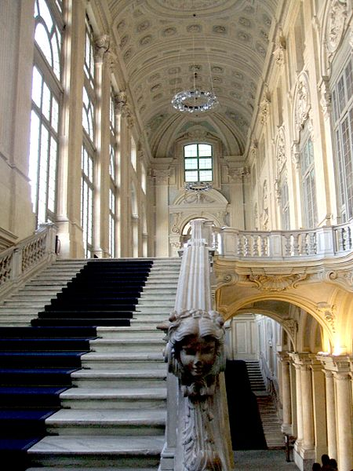
The staircase of the Baroque Palazzo Madama, Turin
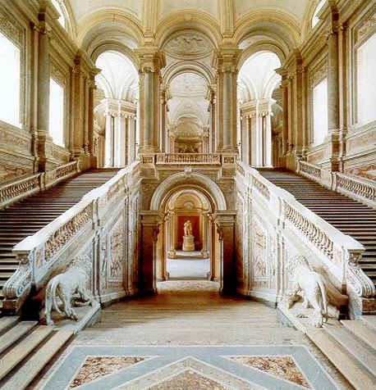
The Baroque staircase in the Palace of Caserta
It was the largest palace and one of the largest buildings erected in Europe during the 18th century. The palace has some 1,200 rooms, including two dozen state apartments, a large library, and a theatre. The royal palace has more than 40 monumental rooms completely decorated with frescoes.

- 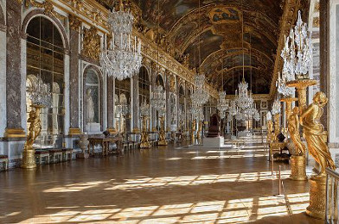
Hall of Mirrors (Versailles)
Versailles' most famous room is the Hall of Mirrors, whose mirrors have the same dimensions as the windows they stand opposite

